|  |
| --- |
|  |
| ChesterPro  : How to copy remote chesterpro database to local database |
|  |

Table of Contents

ChesterPro Database 2

1.0 Copy remote chesterpro database to local database 2

**STEP 1:** 2

**STEP 2:** 2

**STEP 3:** 2

**STEP 4:** 3

**STEP 5:** 3

Figure 1 Perform Backup 3

Figure 2 Restore to local database 4

## ChesterPro Database

A database is an organized collection of information. ChesterPro database is where all collected pieces of information are being kept so that it can be easily accessed and managed.

## Copy remote chesterpro database to local database

### **STEP 1:**

Configure connection information and password for user ‘backup’. This step is performed only once.

* Copy ‘pgpass.conf’ file into the directories below

1. C:\Users\<Your Windows profile name Here>\AppData\Roaming\pgAdmin

Eg. C:\Users\Lateef\AppData\Roaming\pgAdmin

1. C:\Apps\PostgreSQL\<Your postgres version number>\data

Eg. C:\Apps\PostgreSQL\10\data

### **STEP 2:**

On pgAdmin connect to the remote database ‘chesterpro_dev_db’ using the credentials for THE‘backup’ user.

### **STEP 3:**

On pgAdmin perform backup on remote ‘chesterpro_dev_db’ using role ‘postgres’ and the data options as shown below. Then wait for the process to be completed.

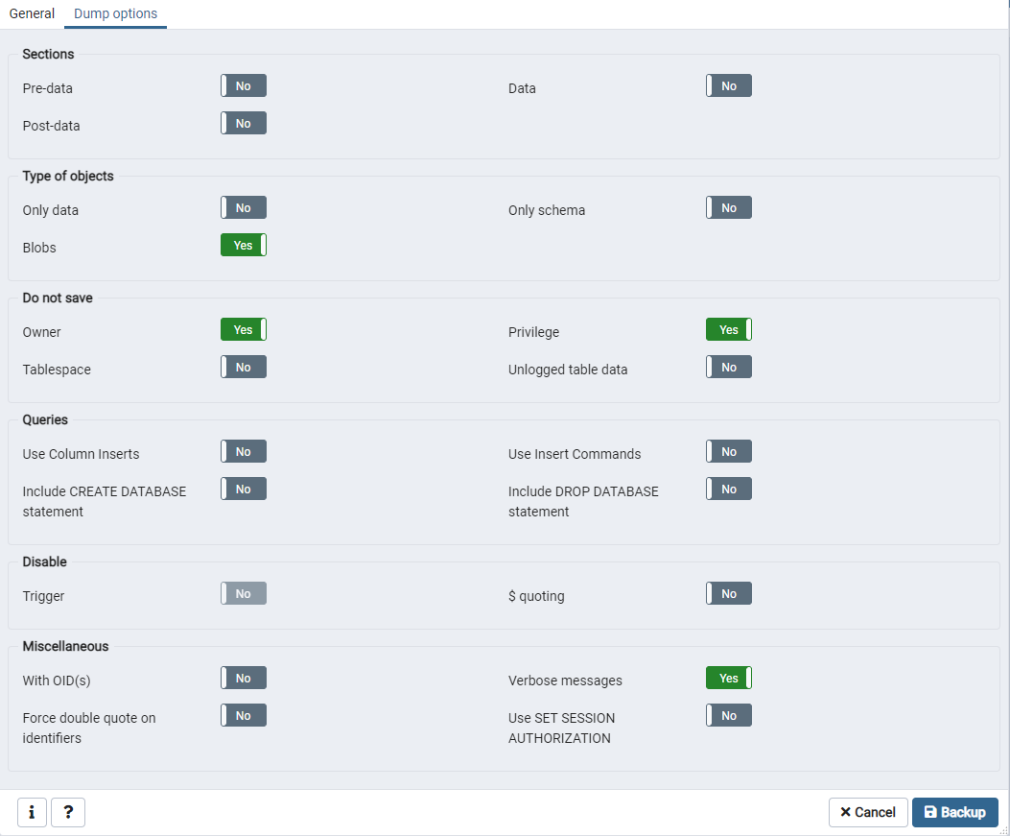

Figure 1 Perform Backup

### **STEP 4:**

On pgAdmin connect to the local database ‘chesterpro_dev_db’ and run the statements below in query tool.

* DROP SCHEMA public CASCADE
* CREATE SCHEMA public
* GRANT ALL ON SCHEMA public TO postgres
* GRANT ALL ON SCHEMA public TO public
* GRANT ALL ON SCHEMA public TO chesterpro_dev

### **STEP 5:**

On pgAdmin restore to the local database ‘chesterpro_dev_db’ the dump file that was created in step 3.

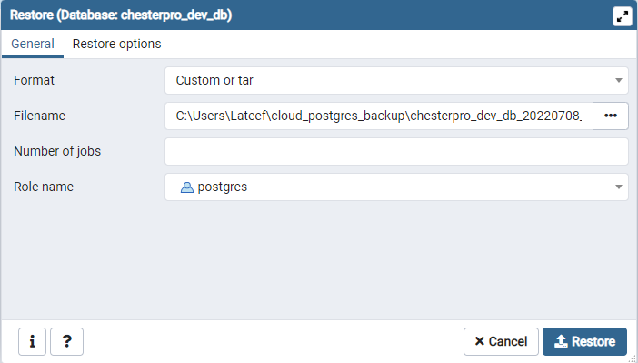

Figure 2 Restore to local database